

Lab 6

R Practical



March 12, 2022

Matt wehnert, Julie Nguyen, William jackson

CSI 475

R Integration with Tableau Setup (If not done so already)

1. Boot up R Studio and log into MySQL with your credentials.
2. Boot up Tableau.
3. Go the R Studio console and type in the command: install.packages(“Rserve”);
4. Hit enter or run.
5. Enter the next command in the R Console: library(Rserve)
6. And hit enter/run.
7. Enter the final command: Rserve() and hit enter
8. Next, install the mvoutlier library by typing in the command: install.packages(“mvoutlier”).
9. Hit enter/run. Your console window should look like this after each command has successfully run:

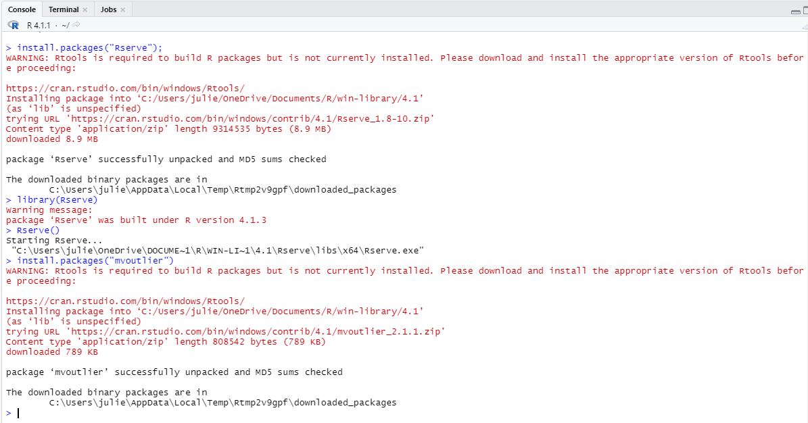

1. Go to Tableau and hover over Help.
2. Click on Manage Analytics Extensions Connection and sign in with your credentials to initiate the connection (optional) or test the connection to see if Rserve is running and connected with Tableau.

Result:

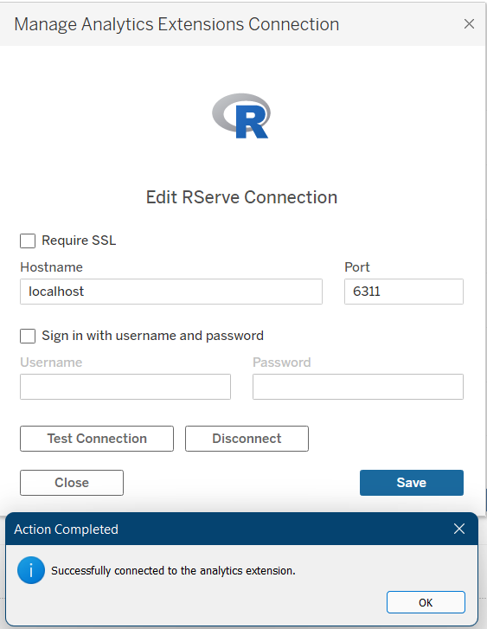

1. Exit out of the Manage Analytics Extensions Connection popup window and proceed to get started on the lab.

R Integration with Tableau Analysis

1. Going back to the previous lab that was worked on, we will be adding on to that lab 5 project. Click on lab5 and create a new worksheet, this will be sheet 13.
2. Put the Year Week ISO into the columns and the SUM of unknown dose into the rows.
3. In the marks section, change the chart to a shape chart. You can change the marker to a filled x. Adjusting the size of the markers is optional.
4. Create a calculated field called “Outlier”.
5. Type in the following R script: SCRIPT_REAL(

"library(mvoutlier);

sign2(cbind(.arg1))$wfinal01",

sum([Unknown Dose]))

1. Drag the outlier calculated field into colors block and your result should be this following 5 outlier data points in light blue:

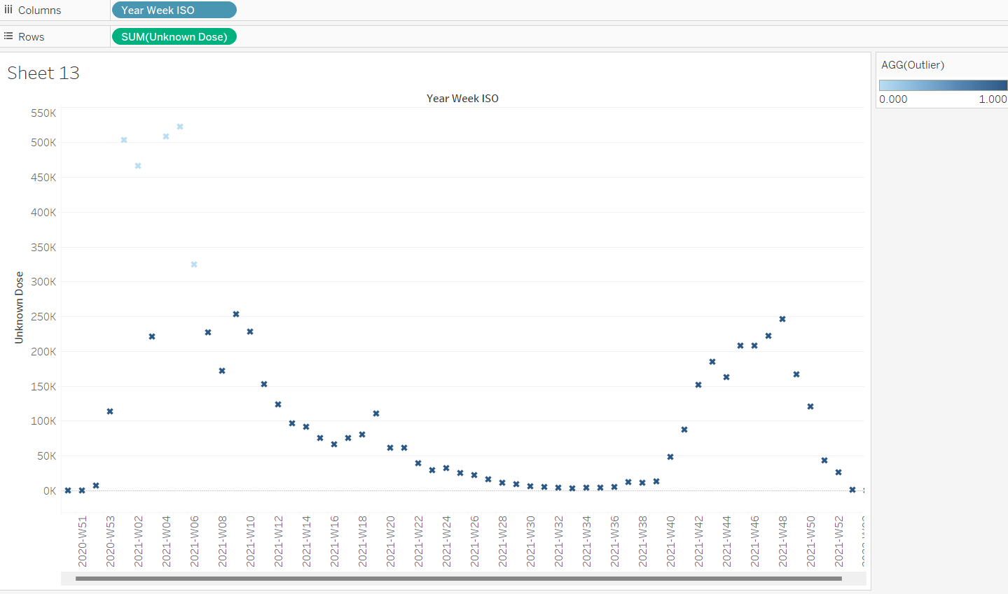

1. Remove the old outlier calculated field from the section and modify the outlier calculated field with the new R script:

IF

SCRIPT_REAL(

"library(mvoutlier);

sign2(cbind(.arg1))$wfinal01",

sum([Unknown Dose]))

= 0

THEN "Outlier"

ELSE "Normal"

END

1. Click OK and drag the new outlier calculated field into color. Your end result should be this:

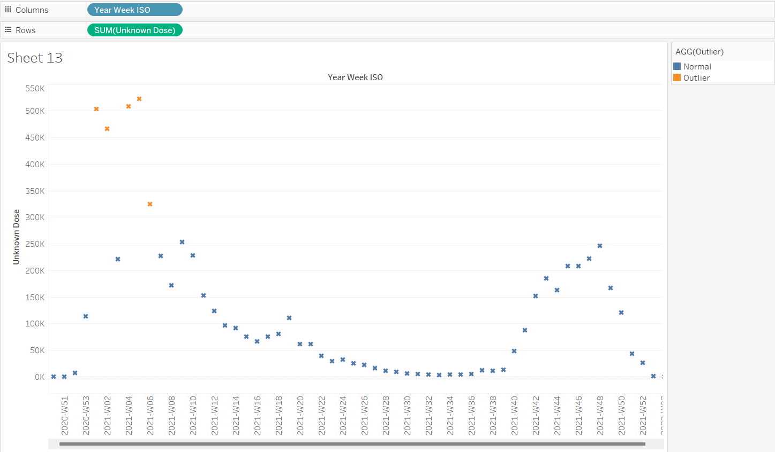

1. You can change the outliers shape and color per your liking.
2. Save your work as lab6.twb and close out of Tableau.

Conclusion

My group and I learned how to use R script in Tableau for convenience to find out about outliers in our data. We used a YouTube tutorial as guidance when articles and documentations did not help. Libraries including Rserve and mvoutlier were used as part of this technique.

# Insights

In the Europe dataset, we found 5 outlier datapoints concerning unknown doses. The outliers implicate that the doses could have been either experimental or during the vaccine shortage back in early 2021 there were people who received undocumented vaccines.

# Challenges & Resolution

Some of the fields had incompatible types and so we had to change it to be able to run the query and calculated fields.

The R script that was made before without proper understanding gave an error pertaining infinite zero values but this was fixed given the proper field in the calculations.